**Table 1: Demographic, clinical characteristics, and routine laboratory investigations of hypogonadal diabetics (Group I), eugonadal diabetics (Group II) and control group (Group III).**

|  |  |  |  |  |  |  |  |  |
| --- | --- | --- | --- | --- | --- | --- | --- | --- |
|  |  | **Hypogonadal DM (I)** | **Euogonadal DM (II)** | **Control (III)** | **P value** | | | |
| **N=50** | **N=50** | **N=50** | **Among 3 groups** | **I vs II** | **I vs III** | **II vs III** |
| **Age (years)** | *Mean ± SD* | 47.5±3 | 46.9±3.6 | 46.8±2.3 | 0.427 | 0.540 | 0.459 | 0.990 |
| **Duration (years)** | *Mean ± SD* | 7.8±0.8 | 7.6±0.7 |  |  | 0.193 |  |  |
| **Treatment type** | Oral  Insulin | 24(48%)  26(52%) | 27(54%)  23(46%) |  |  | 0.548 |  |  |
| **SBP (mmHg)** | *Mean ± SD* | 146.6±7 | 133.5±6.8 | 117.4±3.7 | <0.001* | <0.001* | <0.001* | <0.001* |
| **DBP (mmHg)** | *Mean ± SD* | 90.9±4.7 | 83.3±3.3 | 76.4±3.8 | <0.001* | <0.001* | <0.001* | <0.001* |
| **BMI (kg/m2)** | *Mean ± SD* | 30.6±1 | 29.1±0.8 | 22.8±0.7 | <0.001* | <0.001* | <0.001* | <0.001* |
| **WC (cm)** | *Mean ± SD* | 105.7±2.3 | 103.5±1.8 | 89.1±0.7 | <0.001* | <0.001* | <0.001* | <0.001* |
| **W/H** | *Mean ± SD* | 1±0 | 1±0 | 0.9±0 | <0.001* | 0.614 | <0.001* | <0.001* |
| **NC (cm)** | *Mean ± SD* | 39.7±1.3 | 38.3±1.1 | 36.8±0.2 | <0.001* | <0.001* | <0.001* | <0.001* |
| **Hb (g/dl)** | *Mean ± SD* | 12.3±0.3 | 12.4±0.3 | 12.4±0.3 | 0.411 | 0.843 | 0.380 | 0.719 |
| **TLC (103/µL)** | *Mean ± SD* | 7.6±0.7 | 7.6±0.6 | 7.7±0.5 | 0.825 | 0.993 | 0.828 | 0.885 |
| **Platelets**  **(103/µL)** | *Mean ± SD* | 284.8±22.6 | 288.9±19.5 | 291.8±11 | 0.166 | 0.512 | 0.143 | 0.710 |
| **Bilirubin (mg/dl)** | *Mean ± SD* | 1±0.1 | 1±0.1 | 1±0.1 | 0.551 | 0.823 | 0.873 | 0.520 |
| **Creatinine (mg/dl)** | *Mean ± SD* | 0.9±0.1 | 1±0.1 | 0.9±0.1 | 0.215 | 0.312 | 0.498 | 0.122 |

***SBP: systolic blood pressure, DBP: diastolic blood pressure, BMI: body mass index, WC: waist circumference, W/H: waist hip ratio, NC: neck circumference, HB: hemoglobin, TLC: total leucocytic count,***

**Table 2: Comparison between carbohydrate metabolic parameters and lipid profile in all groups.**

|  |  |  |  |  |  |  |  |  |
| --- | --- | --- | --- | --- | --- | --- | --- | --- |
|  |  | **Hypogonadal DM (I)** | **Euogonadal DM (II)** | **Control (III)** | **P value** | | | |
| **N=50** | **N=50** | **N=50** | **Among 3 groups** | **I vs II** | **I vs III** | **II vs III** |
| **HbA1c (%)** | *Range*  *Mean ± SD* | (6.9-7.7)  7.2±0.2 | (6.5-7.8)  7.1±0.4 | (4.5-5.2)  4.9±0.2 | <0.001* | 0.247 | <0.001* | <0.001* |
| **FBS (mg/dl)** | *Range*  *Mean ± SD* | (123-143)  135.8±4.1 | (122-145)  134.6±5.7 | (98-109)  103.4±3.1 | <0.001* | 0.352 | <0.001* | <0.001* |
| **Fasting insulin**  **(mIU/L)** | *Range*  *Mean ± SD* | (23.4-47)  33.1±4.4 | (17-33)  21.9±3.7 | (17-19.2)  18.1±0.6 | <0.001* | <0.001* | <0.001* | <0.001* |
| **HOMA IR** | *Range*  *Mean ± SD* | (7.9-16)  11.2±1.7 | (5.2-9)  6.8±0.9 | (2.4-2.6)  2.5±0.1 | <0.001* | <0.001* | <0.001* | <0.001* |
| **Triglycerides (mg/dl)** | *Range*  *Mean ± SD* | (200-270)  240.5±13.3 | (168-238)  188.8±17 | (137-148)  142.7±3.2 | <0.001* | <0.001* | <0.001* | <0.001* |
| **LDL-C (mg/dl)** | *Range*  *Mean ± SD* | (103-148)  123.1±9.2 | (104-1142)  122.1±8.5 | (88-99)  93.5±3.7 | <0.001* | 0.785 | <0.001* | <0.001* |
| **HDL-C (mg/dl)** | *Range*  *Mean ± SD* | (52-60)  56.5±2 | (51-61)  56.4±2.4 | (60-65)  61.7±1.3 | <0.001* | 0.950 | <0.001* | <0.001* |
| **Total cholesterol (mg/dl)** | *Range*  *Mean ± SD* | (215-300)  238.3±18.8 | (210-288)  234±15.9 | (186-199)  191.4±3.8 | <0.001* | 0.292 | <0.001* | <0.001* |

***FBS: fasting blood sugar, HOMA IR: homeostasis model assessment of insulin resistance, LDL-C: low density lipoprotein cholesterol, HDL-C: high density lipoprotein cholesterol.***

**Table 3: Comparison between sex hormones levels in different groups.**

|  |  |  |  |  |  |  |  |  |
| --- | --- | --- | --- | --- | --- | --- | --- | --- |
|  |  | **Hypogonadal DM (I)** | **Euogonadal DM (II)** | **Control (III)** | **P value** | | | |
| **N=50** | **N=50** | **N=50** | **Among 3 groups** | **I vs II** | **I vs III** | **II vs III** |
| **TT (nmol/L)** | *Range*  *Mean ± SD* | (6.9-9)  8±0.6 | (16-19)  17.4±0.8 | (16-18.6)  17.4±0.8 | <0.001* | <0.001* | <0.001* | 0.999 |
| **SHBG (nmol/L)** | *Range*  *Mean ± SD* | (22-30)  26.1±2.2 | (23-30.4)  26.7±2.4 | (32-46)  37.4±3.8 | <0.001* | 0.526 | <0.001* | <0.001* |
| **CfT (nmol/L)** | *Range*  *Mean ± SD* | (0.2-0.2)  0.2±0 | (0.4-0.5)  0.4±0 | (0.4-0.5)  0.4±0 | <0.001* | <0.001* | <0.001* | 0.275 |
| **FSH (IU/L)** | *Range*  *Mean ± SD* | (6.2-7.1)  6.57±0.3 | (6.2-7.2)  6.63±0.3 | (6.1-7)  6.57±0.3 | 0.331 | 0.391 | 0.999 | 0.413 |
| **LH (IU/L)** | *Range*  *Mean ± SD* | (5-6.1)  5.5±0.3 | (5.2-6.1)  5.6±0.3 | (5.2-6.1)  5.7±0.3 | 0.086 | 0.294 | 0.077 | 0.774 |

***TT: total testosterone, SHBG:*** ***sex hormone binding globulin, CfT:*** ***calculated free testosterone, FSH:*** ***follicular stimulating hormone, LH: luteinizing hormone***

**Table 4: Comparison between imaging and functional liver status in all groups.**

|  |  |  |  |  |  |  |  |  |
| --- | --- | --- | --- | --- | --- | --- | --- | --- |
|  |  | **Hypogonadal DM (I)** | **Euogonadal DM (II)** | **Control (III)** | **P value** | | | |
| **N=50** | **N=50** | **N=50** | **Among 3 groups** | **I vs II** | **I vs III** | **II vs III** |
| **Liver US (Degree of fatty liver)** | No  Mild  Moderate  Severe | 6(12%)  16(32%)  21(42%)  7(14%) | 23(46%)  13(26%)  9(18%)  5(10%) | 50(100%)  0(0%)  0(0%)  0(0%) | <0.001* | 0.001* | <0.001* | <0.001* |
| **NFS** | *Median*  *IQR* | -1.5  (-1.6: -1.5) | -1.6  (-1.7: -1.5) |  |  | 0.026* |  |  |
| **ALT (IU/L)** | *Median*  *IQR* | 35  (31-40) | 28  (26-29) | 23  (22-25) | <0.001* | <0.001* | <0.001* | <0.001* |
| **AST (IU/L)** | *Median*  *IQR* | 33  (28-38) | 25  (23.8-26.3) | 21.5  (20-23) | <0.001* | <0.001* | <0.001* | <0.001* |
| **Albumin (g/dl)** | *Range*  *Mean ± SD* | (3.7-4.1)  3.9±0.1 | (3.7-4.2)  3.9±0.2 | (3.7-4.2)  3.9±0.1 | 0.120 | 0.100 | 0.496 | 0.617 |
| **INR** | *Range*  *Mean ± SD* | (0.9-1.1)  1±0.05 | (0.95-1.1)  0.99±0.1 | (1-1.1)  1±0.02 | 0.21 | 0.19 | 0.34 | 0.45 |

***US: ultrasonography, NFS: NAFLD fibrosis score, ALT: alanine transaminase, AST: aspartate transaminase, INR: international*** ***normalized ratio***

**Figure 1: Ultrasonographic fatty liver degrees in hypogonadal, eugonadal and control groups.**

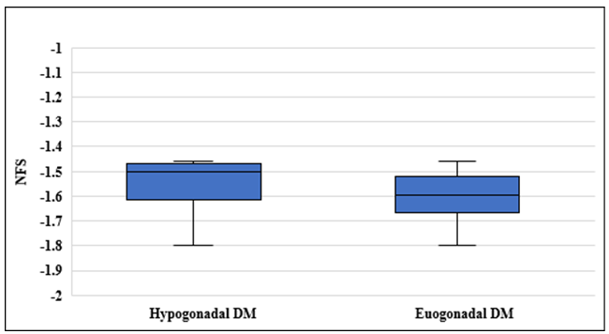

**Figure 1: NFS in hypogonadal and eugonadal groups.**

**Table 5: Comparison between total monocytes % and CD 16+ monocytes subset % in all groups.**

|  |  |  |  |  |  |  |  |  |
| --- | --- | --- | --- | --- | --- | --- | --- | --- |
|  |  | **Hypogonadal DM (I)** | **Euogonadal DM (II)** | **Control (III)** | **P value** | | | |
| **N=50** | **N=50** | **N=50** | **Among 3 groups** | **I vs II** | **I vs III** | **II vs III** |
| **Total monocytes (%)** | *Range*  *Mean ± SD* | (5.2-12.4)  6.9±1.8 | (5-7.8)  5.8±0.7 | (4.2-6.2)  5.1±0.5 | <0.001* | <0.001* | <0.001* | 0.023* |
| **CD16+ monocytes (%)** | *Range*  *Mean ± SD* | (7.2-20)  14±1.9 | (7.5-14.5)  10.4±1.3 | (7.5-8.5)  8±0.3 | <0.001* | <0.001* | <0.001* | <0.001* |

**Table 6: Correlation between total testosterone level, anthropometric measurements, metabolic and inflammatory parameters (total and inflammatory monocytes) in diabetic male patients.**

|  |  |  |
| --- | --- | --- |
|  | **TT (nmol/L)** | |
| **r** | **P value** |
| **Duration of diabetes (years)** | -0.213 | *0.431* |
| **SBP (mmHg)** | -0.754 | ***<0.001\**** |
| **DBP (mmHg)** | -0.730 | ***<0.001\**** |
| **BMI (Kg/m2)** | -0.686 | ***<0.001\**** |
| **WC (cm)** | -0.544 | ***<0.001\**** |
| **W/H** | 0.135 | *0.181* |
| **NC (cm)** | -0.562 | ***<0.001\**** |
| **Fasting insulin ( mIU/L)** | -0.850 | ***<0.001\**** |
| **HOMA IR** | -0.886 | ***<0.001\**** |
| **Triglycerides (mg/dl)** | -0.905 | ***<0.001\**** |
| **LDL-C (mg/dl)** | -0.140 | *0.165* |
| **HDL-C (mg/dl)** | -0.045 | *0.654* |
| **Total cholesterol (mg/dl)** | -0.205 | *0.060* |
| **Total monocytes (%)** | -0.454 | ***<0.001\**** |
| **CD16+ monocytes (%)** | -0.792 | ***<0.001\**** |

***SBP: systolic blood pressure, DBP: diastolic blood pressure, BMI: body mass index, WC: waist circumference, W/H: waist*** ***hip ratio, NC: neck circumference, HOMA IR: homeostasis model of assessment of insulin resistance, LDL-C: low density lipoprotein cholesterol, HDL-C: high density lipoprotein cholesterol.***

**Table 7: Correlation between NASH fibrosis score (NFS), anthropometric measurements, metabolic and inflammatory parameters (total and inflammatory monocytes) in diabetic male patients.**

|  |  |  |
| --- | --- | --- |
|  | **NFS** | |
| **r** | **P value** |
| **Duration of diabetes (years)** | 0.421 | *0.214* |
| **SBP (mmHg)** | 0.515 | ***<0.001\**** |
| **DBP (mmHg)** | 0.480 | ***<0.001\**** |
| **BMI (Kg/m2)** | 0.645 | ***<0.001\**** |
| **WC (cm)** | 0.545 | ***<0.001\**** |
| **W/H** | 0.336 | ***0.001\**** |
| **NC (cm)** | 0.523 | ***<0.001\**** |
| **TT (nmo/L)** | -0.203 | ***0.043\**** |
| **CFT (nmol/L)** | -0.157 | *0.119* |
| **Fasting insulin ( mIU/L)** | 0.544 | ***<0.001\**** |
| **HOMA IR** | 0.470 | ***<0.001\**** |
| **Triglycerides (mg/dl)** | 0.437 | ***<0.001\**** |
| **LDL-C (mg/dl)** | 0.677 | *0.121* |
| **HDL-C (mg/dl)** | 0.272 | *0.511* |
| **Total cholesterol (mg/dl)** | 0.815 | *0.099* |
| **Total monocytes (%)** | 0.868 | ***<0.001\**** |
| **CD16+ monocytes (%)** | 0.511 | ***<0.001\**** |

***SBP: systolic blood pressure, DBP: diastolic blood pressure, BMI: body mass index, WC: waist circumference, W/H: waist hip ratio, NC: neck circumference, TT: total testosterone, CfT; calculated free testosterone, HOMA IR: homeostasis model of assessment of insulin resistance, LDL-C: low density lipoprotein cholesterol, HDL-C: high density lipoprotein cholesterol, NFS: NAFLD fibrosis score.***

**Table 8: Correlation between total monocytes %, anthropometric measurements, metabolic and liver status in diabetic male patients.**

|  |  |  |
| --- | --- | --- |
|  | **Total monocytes (%)** | |
| **r** | **P value** |
| **Duration of diabetes (years)** | 0.531 | *0.221* |
| **SBP (mmHg)** | 0.649 | ***<0.001\**** |
| **DBP (mmHg)** | 0.621 | ***<0.001\**** |
| **BMI (Kg/m2)** | 0.748 | ***<0.001\**** |
| **WC (cm)** | 0.618 | ***<0.001\**** |
| **W/H** | 0.199 | ***0.047\**** |
| **NC (cm)** | 0.639 | ***<0.001\**** |
| **TT (nmol/L)** | -0.454 | ***<0.001\**** |
| **CFT (nmol/L)** | -0.418 | ***<0.001\**** |
| **Fasting insulin (mIU/L)** | 0.737 | ***<0.001\**** |
| **HOMA IR** | 0.700 | ***<0.001\**** |
| **Triglycerides (mg/dl)** | 0.615 | ***<0.001\**** |
| **LDL-C (mg/dl)** | 0.713 | *0.422* |
| **HDL-C (mg/dl)** | 0.267 | *0.532* |
| **Total cholesterol (mg/dl)** | 0.809 | *0.082* |
| **NFS** | 0.868 | ***<0.001\**** |

***SBP: systolic blood pressure, DBP: diastolic blood pressure, BMI: body mass index, WC: waist circumference, W/H: waist hip ratio, NC: neck circumference, TT: total testosterone, CfT; calculated free testosterone HOMA IR: homeostasis model of assessment of insulin resistance, LDL-C: low density lipoprotein cholesterol, HDL-C: high density lipoprotein cholesterol, NFS: NAFLD fibrosis score***

**Table 9: Correlation between CD 16+ monocytes %, anthropometric measurements, metabolic and liver status in diabetic male patients.**

|  |  |  |
| --- | --- | --- |
|  | **CD16+ monocytes (%)** | |
| **r** | **P value** |
| **Duration of diabetes (years)** | 0.632 | *0.084* |
| **SBP (mmHg)** | 0.825 | ***<0.001\**** |
| **DBP (mmHg)** | 0.813 | ***<0.001\**** |
| **BMI (Kg/mm2)** | 0.702 | ***<0.001\**** |
| **WC (cm)** | 0.699 | ***<0.001\**** |
| **W/H** | 0.101 | *0.315* |
| **NC (cm)** | 0.750 | ***<0.001\**** |
| **TT (nmol/L)** | -0.792 | ***<0.001\**** |
| **CFT (nmol/L)** | -0.761 | ***<0.001\**** |
| **Fasting insulin (mIU/L)** | 0.901 | ***<0.001\**** |
| **HOMA IR** | 0.897 | ***<0.001\**** |
| **Triglycerides (mg/dl)** | 0.874 | ***<0.001\**** |
| **LDL-C (mg/dl)** | 0.523 | *0.215* |
| **HDL-C (mg/dl)** | 0.235 | *0.082* |
| **Total cholesterol (mg/dl)** | 0.511 | *0.112* |
| **NFS** | 0.511 | ***<0.001\**** |

***SBP: systolic blood pressure, DBP: diastolic blood pressure, BMI: body mass index, WC: waist circumference, W/H: waist hip ratio, NC: neck circumference, TT: total testosterone, CfT; calculated free testosterone HOMA IR: homeostasis model of assessment of insulin resistance, LDL-C: low density lipoprotein cholesterol, HDL-C: high density lipoprotein cholesterol, NFS: NAFLD fibrosis score***

**Table 10: Simple logistic regression analysis for prediction of hypogonadism.**

|  |  |  |  |
| --- | --- | --- | --- |
|  | **OR** | **95% CI** | ***P value*** |
| **Total monocytes (%)** | 4.656 | 1.978-10.959 | ***<0.001\**** |
| **CD16+ monocytes (%)** | 3.573 | 2.333-5.474 | ***<0.001\**** |
| **NFS** | 1.676 | 0.780-3.604 | *0.186* |
| **Fatty liver degrees**  *No*  *Mild*  *Moderate*  *Severe* | *Ref.*  4.718  8.944  5.367 | 1.481-15.032  2.72-29.412  1.249-23.051 | ***0.009\****  ***<0.001\****  ***0.024\**** |

**Table 11: ROC curve analysis of total monocyte % and CD 16+ subset for prediction of hypogonadism.**

|  |  |  |
| --- | --- | --- |
|  | **Total monocytes (%)** | **CD16+ monocytes (%)** |
| **Optimal cutoff point** | > 6 | > 13 |
| **AUC** | 0.827 | 0.936 |
| **95% CI** | 0.738-0.895 | 0.868-0.975 |
| **P value** | **<0.001\*** | **<0.001\*** |
| **Sensitivity** | 90 | 90 |
| **Specificity** | 80 | 98 |
| **PPV** | 81.8 | 97.8 |
| **NPV** | 88.9 | 90.7 |
| **Accuracy** | 85 | 94 |

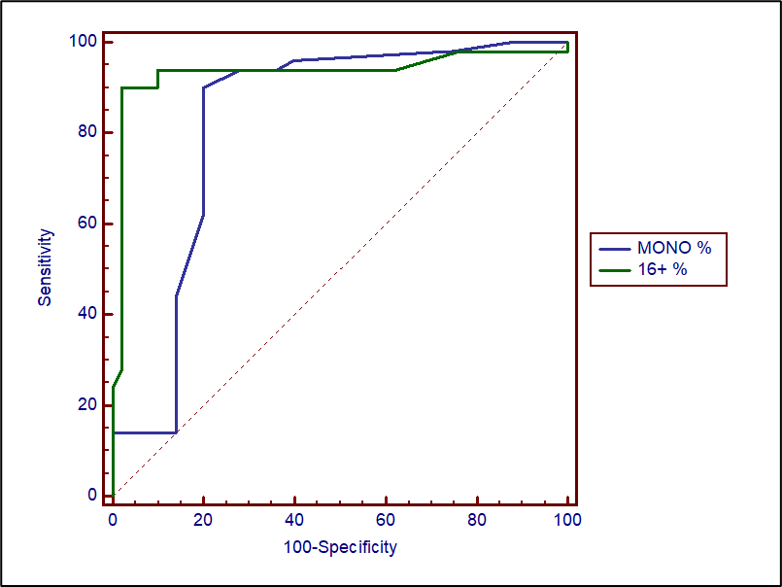

**Figure 2: ROC curve analysis for total monocyte % and CD 16+ subset % prediction of hypogonadism**